

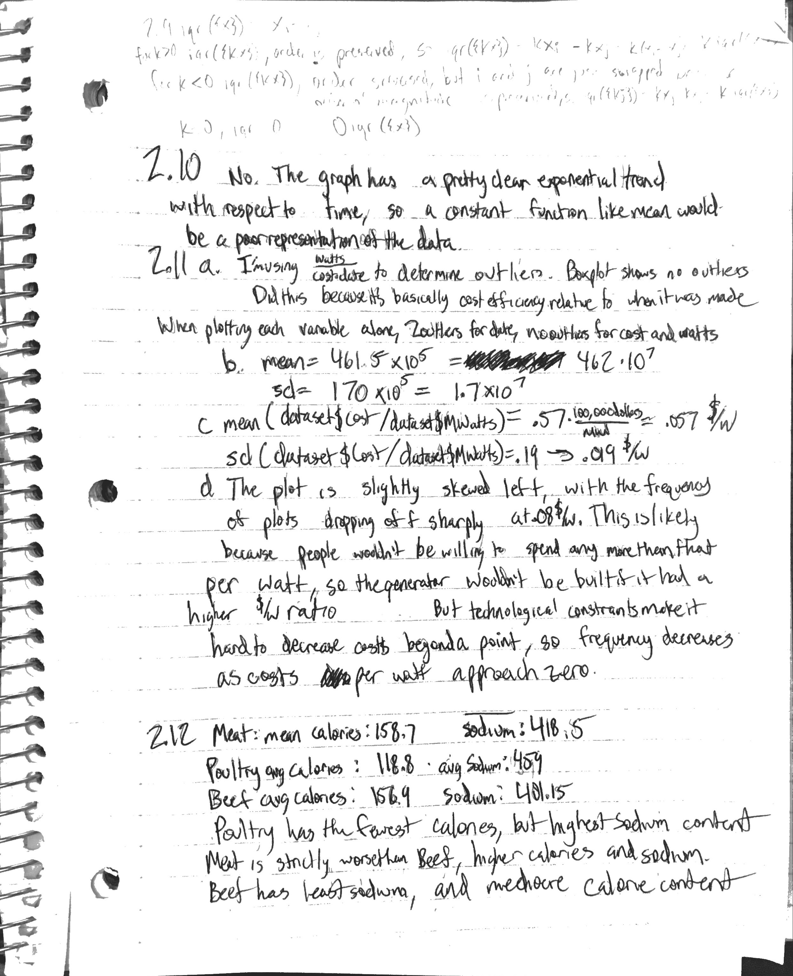

2.13

I typed this page up because my handwriting was steadily deteriorating and this page was pretty messy

1. Group 3 has 4 outliers and the largest range. If outliers are eliminated, Group 3 has the lowest IQR range and variance. Middle 50% is bounded by 10 and 15 3+ syllable words. Groups 1 and 2 have no outliers, and a more even distribution. After eliminating the outliers of group 3, group 1 has the largest range, and group 2 has the second largest range. Group 1 has the highest median and mean of 3+ syllable words, Group 2 has the second highest in both median and mean, and Group 3 has the lowest median and mean of 3+ syllable words.
2. The three groups have very close median and means, but group 2 has the highest variance, closely followed by group 1. Group 3 has the lowest variance, but also has 3 outliers.

2.14

1. (note: higher ranked means a better school, but refers to lower numerical value in the rank column) Average debt trends downward for higher ranked schools, and the effect continues when you split the top third of private schools into thirds again. For the sake of interest, I also plotted the cost of attendance, and cost was positively correlated with rank. However, highly ranked schools actually gave much more need based aid, so the plot of cost minus aid actually trended downward for highly ranked schools, as shown in my plots.
2. Std(private cost) = 10461, std(public cost) = 4500. Private school tuition has a much higher value and range, so it’s analogous to multiplying public tuition by a scalar, naturally increasing variance and standard deviation because the range is higher.
3. Each third shows that tuition is positively correlated with rank
4. Same as private schools, rank increases with tuition.

All the plots I referenced

2.10

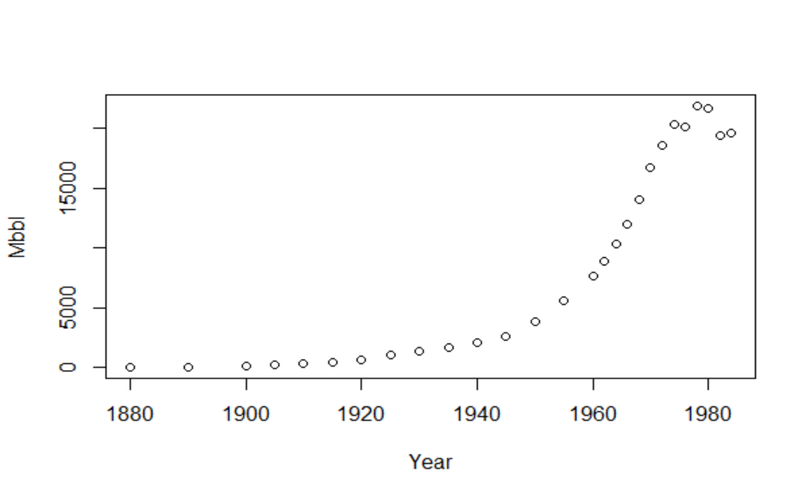

2.11

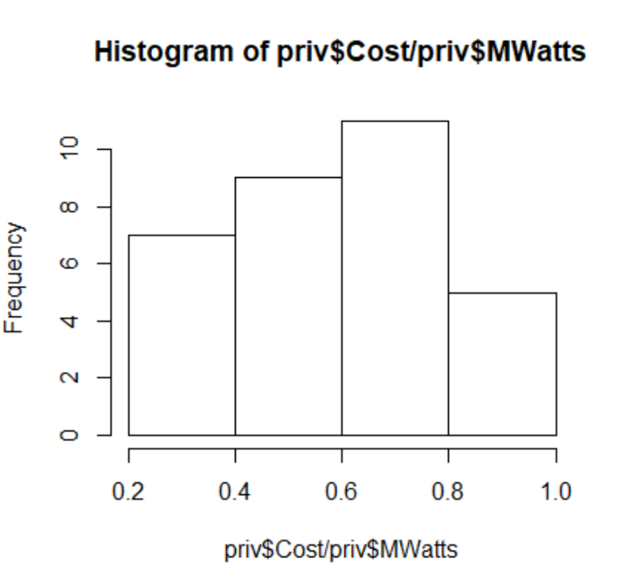

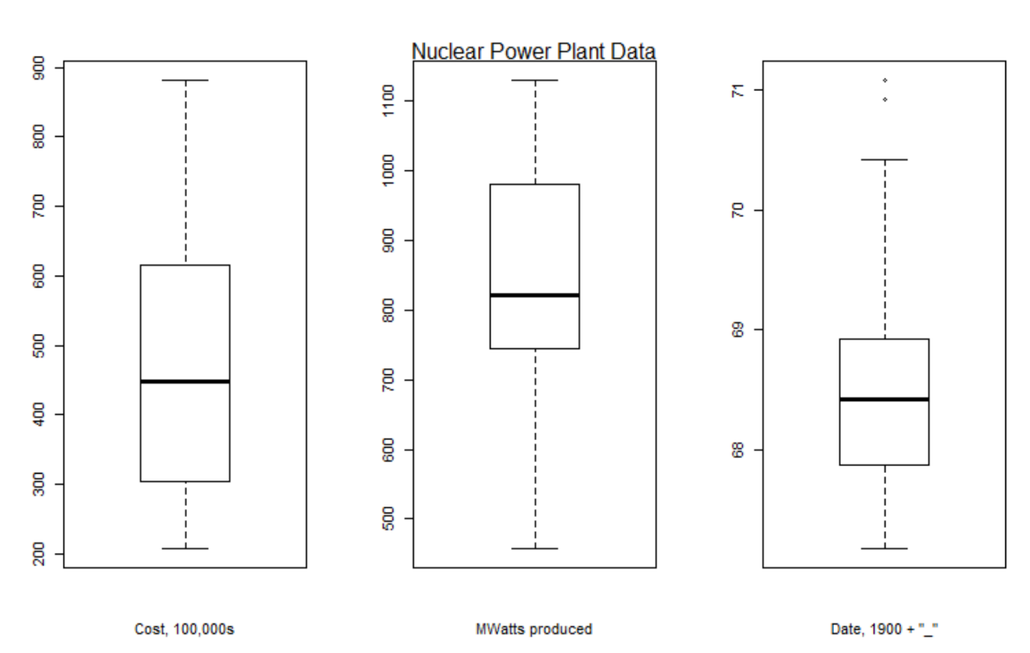

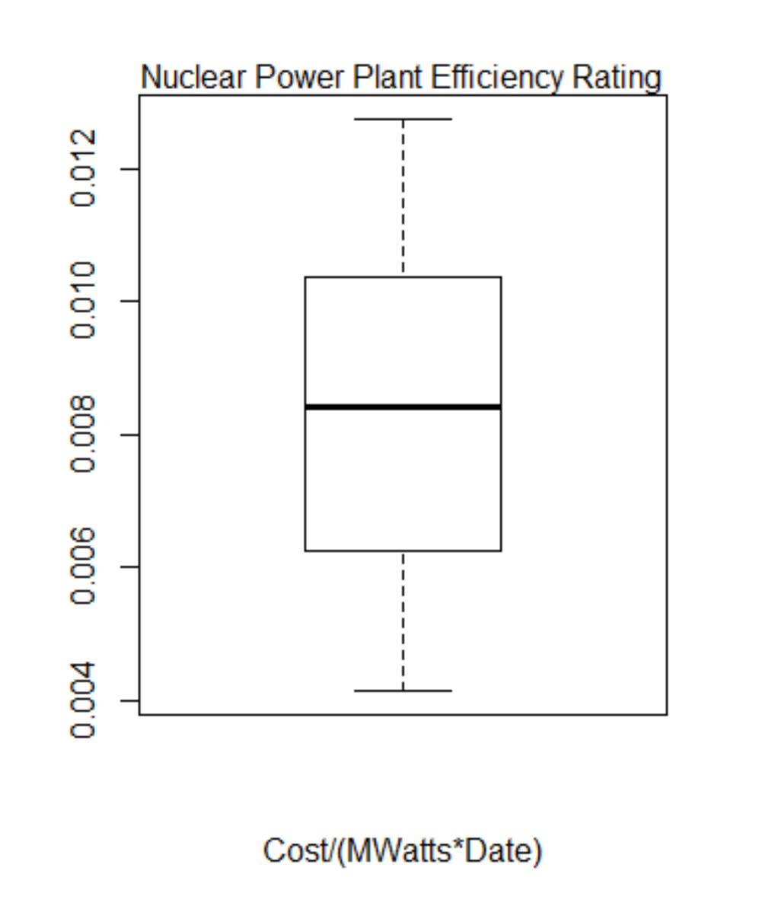

2.12

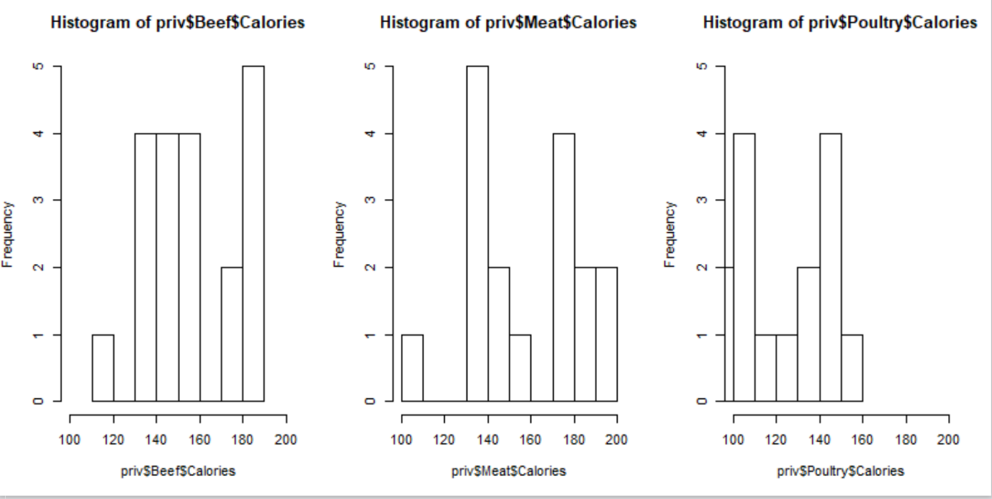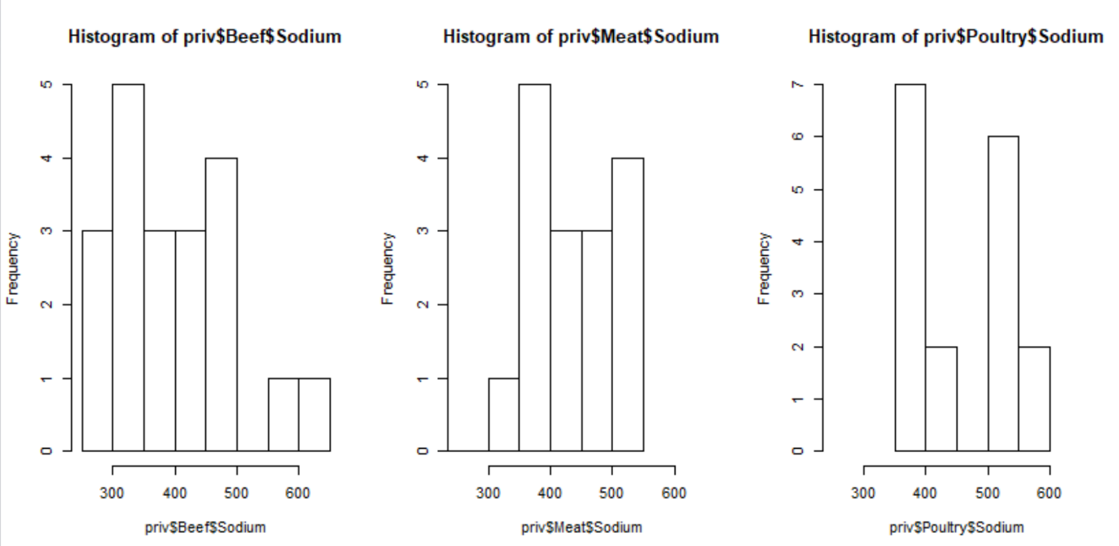

2.13

First graph is 3 + syllable words by group

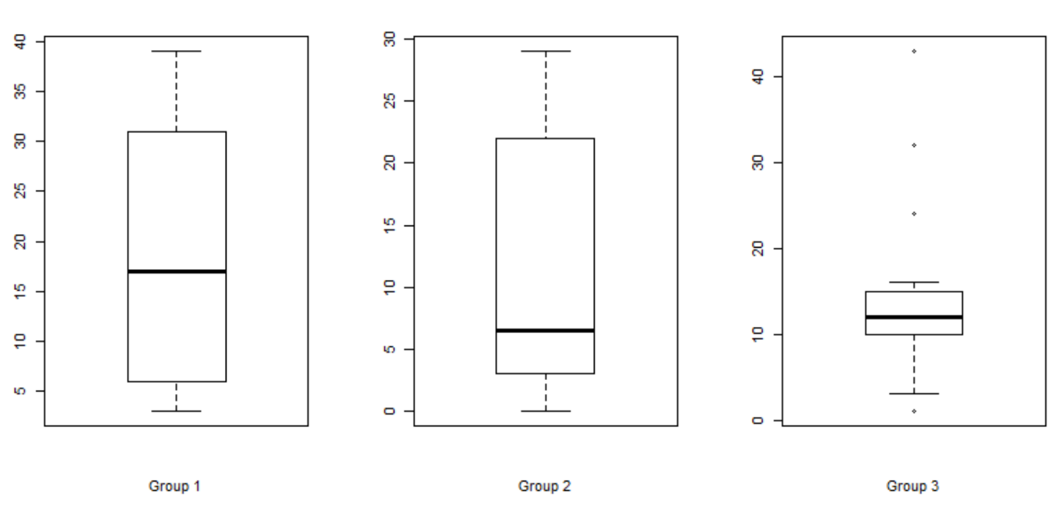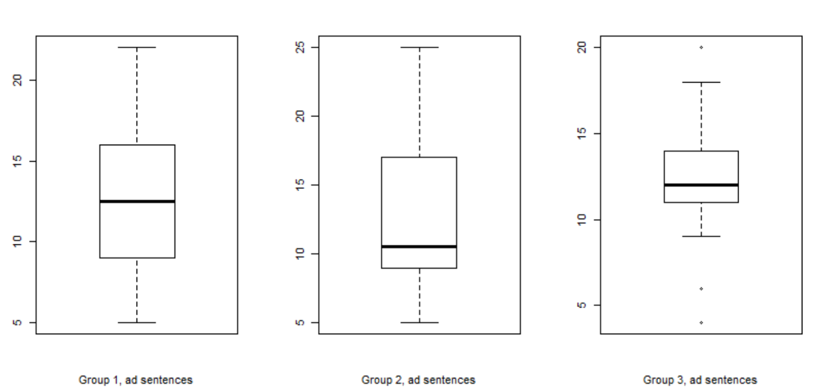

2.14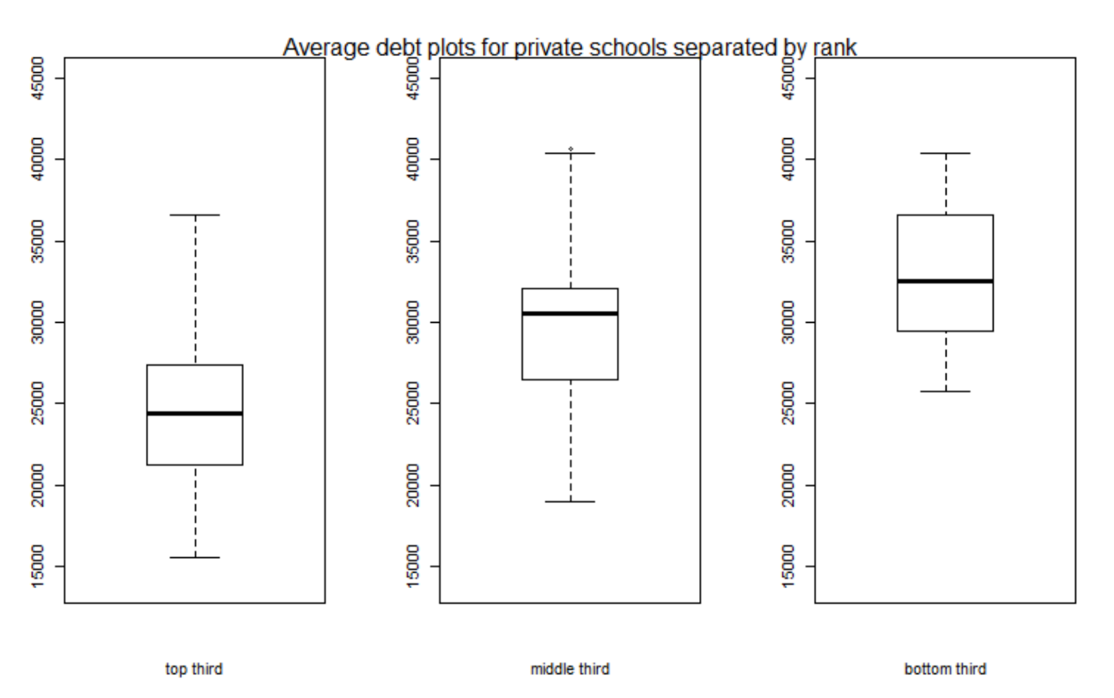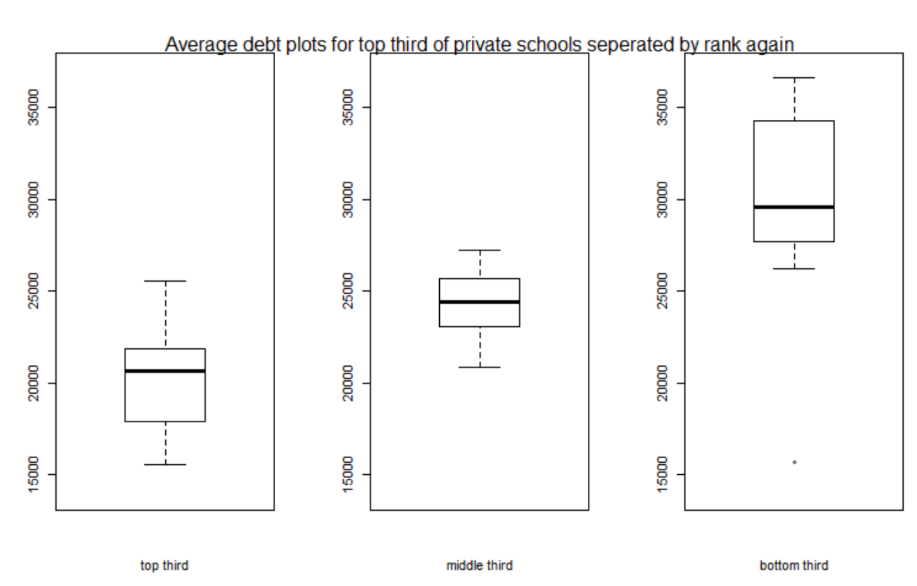

Just straight up cost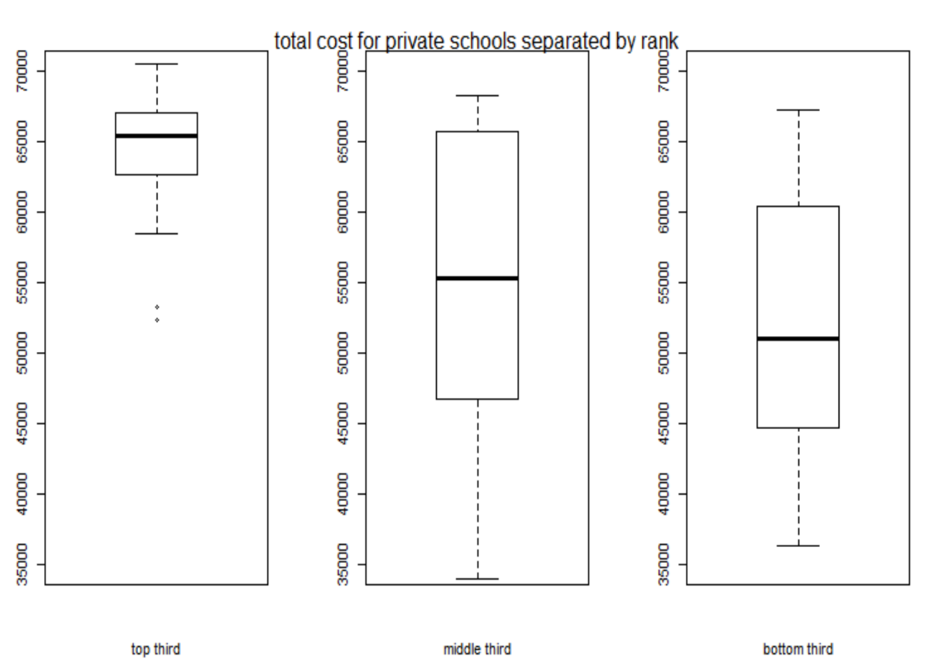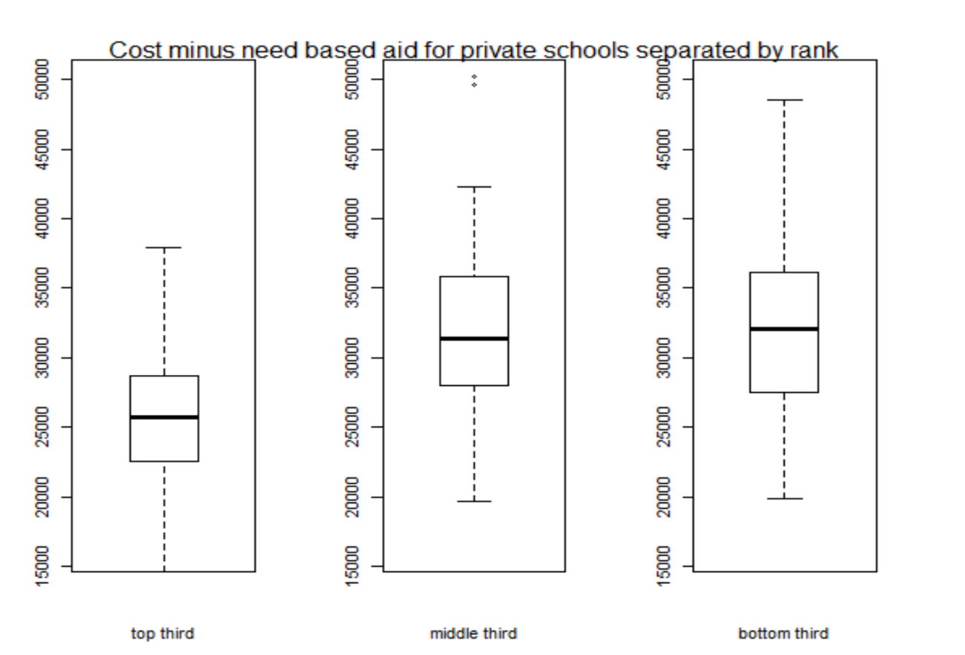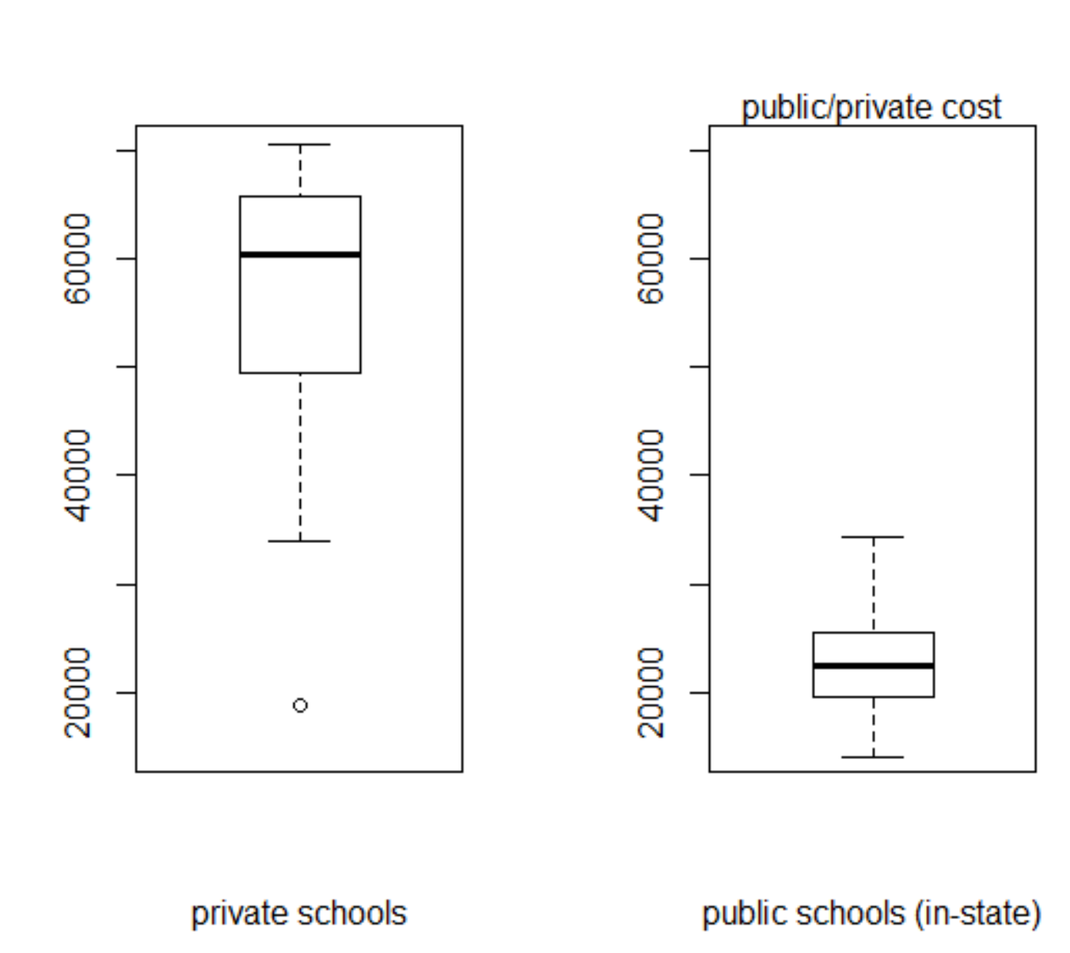

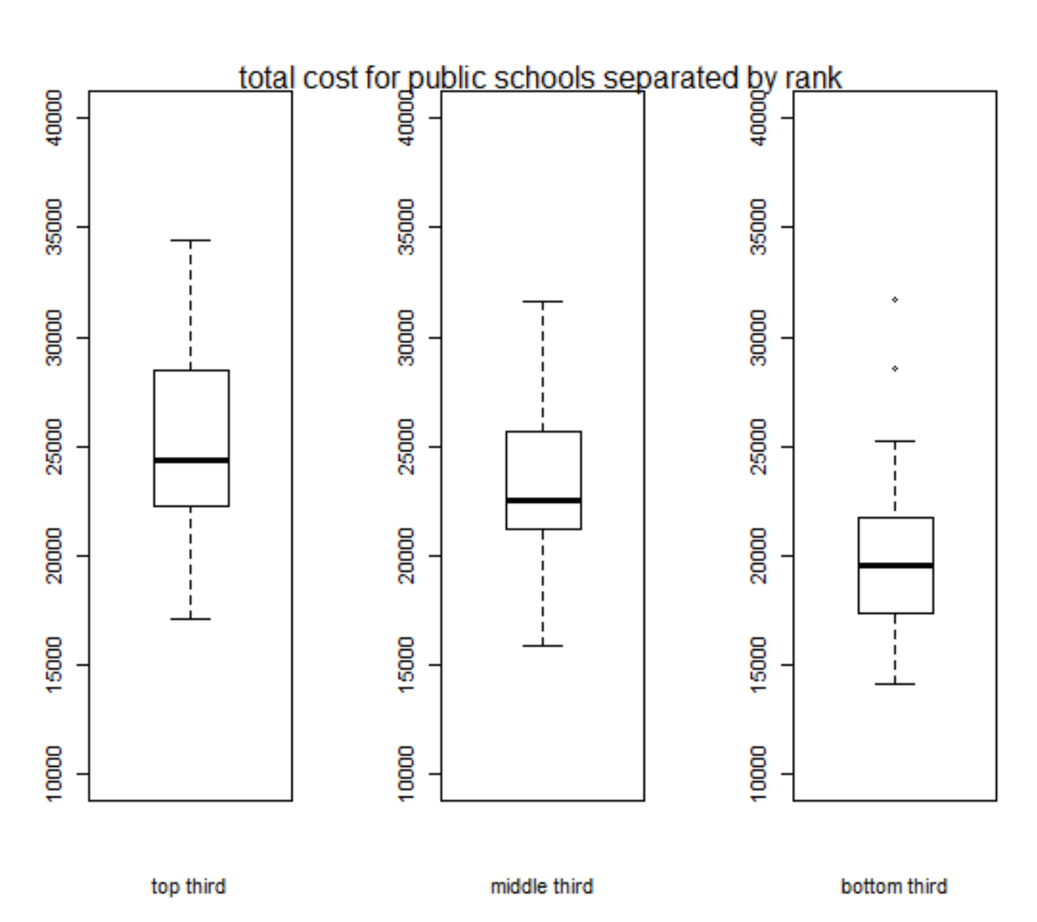

Similar trend as that observed for private schools, just less pronounced due to the smaller range and variance.